Project 1 documentation

I have created class for linked list and array. I initialize the variable with some constant values and variables. In Class I have created the private variables for clock and counting some creation, initialization time with total values

Linked list :
We can snip the linked list.
Insertion and deletion is easy because of head pointer.
Linked list is consider as dynamic data structure because of no fixed size.
Sequential access is not possible. Extra pointer is required for storing the data.
Pointer operation is more complex because of random memory access

void LL_execution()// Linked list function
{
int i,j;
nStart_bit = clock(); //begin the clock
Project1 *pList = NULL; // BaSe_Pointer Creation

for(i = 1; i <= N; i++)
{
Project1* nCurr = new Project1;
nCurr->n_value = rand()%10000;
nCurr->pnext = pList;
pList=nCurr;
}//linked list creation and initialization

nStop_bit = clock(); //Clock freeze
nC_time = (nStop_bit - nStart_bit); //Linked List creation and initialization time
cout << "Linked List :- \n";
cout << "Creation Time:- " << nC_time <<" ";
nStart_bit = clock();////begin the clock
for(j=i=0; i < sizeof(n_Ind)/sizeof(n_Ind[0]) ; i++)
{
Project1* nCurr = new Project1;
nCurr->n_value = rand()%10000; //storing random value between 0 and 10000
nCurr->pnext = NULL;
Project1 * pPrev=pList;
//code for inserting as head
if(n_Ind[i]==0)
{
nCurr->pnext=pList;
pList=nCurr;
continue;
}
j=1;
//code traveling till the index position
while(n_Ind[i]>1 && j< n_Ind[i])
{
pPrev=pPrev->pnext;
j++;
}
nCurr->pnext=pPrev->pnext;
pPrev->pnext=nCurr;

}
nStop_bit = clock(); //clock Freeze
nIn_time = (nStop_bit-nStart_bit); //Linked List insertion time

cout<<"Insertion Time:- " << nIn_time <<" ";
cout<<"\nLinked List (Total time = Creation + Insertion ):- "<<nC_time + nIn_time<<"\n\n";
}

Array:
Array is static data structure and easy to create.
It has fixed size.
It can have sequential access and random access because of index position to the values
It holds similar type of data.
We can not change the values at runtime.

void A_execution()//Array function
{
int i,j;
nStart_bit = clock(); //clock start
int *n_arr =new int [N + (sizeof(n_Ind)/sizeof(n_Ind[0]))]; //Array creation with extra size for insertion
for(i = 0 ; i < N ; i++)
{
n_arr[i] = rand()%10000; //storing random value between 0 and 10000
}
nStop_bit = clock(); //clock stop
nC_time = (nStop_bit-nStart_bit); //array creation and initialization time
cout << "Array :- \n";
cout<<"Creation time:- " << nC_time <<" ";
nStart_bit = clock(); //clock start
for(i = 0 ; i < sizeof(n_Ind)/sizeof(n_Ind[0]) ; i++)//Insert array value at specific index position
{
for(j=N+i; j > n_Ind[i]; j--)
{
n_arr[j] = n_arr[j-1];
}
n_arr[n_Ind[i]]=rand()%10000; //storing random value between 0 and 10000
}

nStop_bit = clock(); //clock stop
nIn_time = (nStop_bit-nStart_bit); //array insertion time
cout << "Insertion time:- " << nIn_time <<"\n";
cout<<"Array (Total time = Creation + Insertion):- "<<nC_time + nIn_time<<"\n\n";
delete[] n_arr; //deleting array
}

Random number can be generated by using rand() function. In between given range

void generateRandomNumbers(int n_arr[],int N)//Random number generation function {
{
srand((unsigned)time(0));//to generate random number

for (int i = 0; i < N; i++)
{
n_arr[i] = (rand()%100) + 1;
}
}

Results:-
Figure1. 20000 values for the comparison

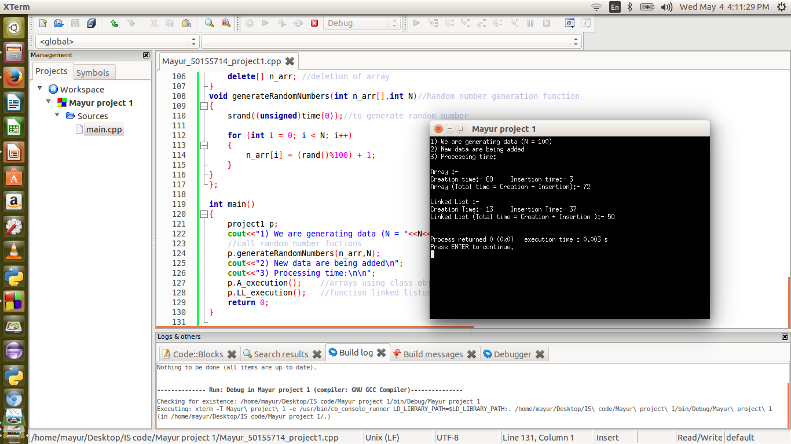
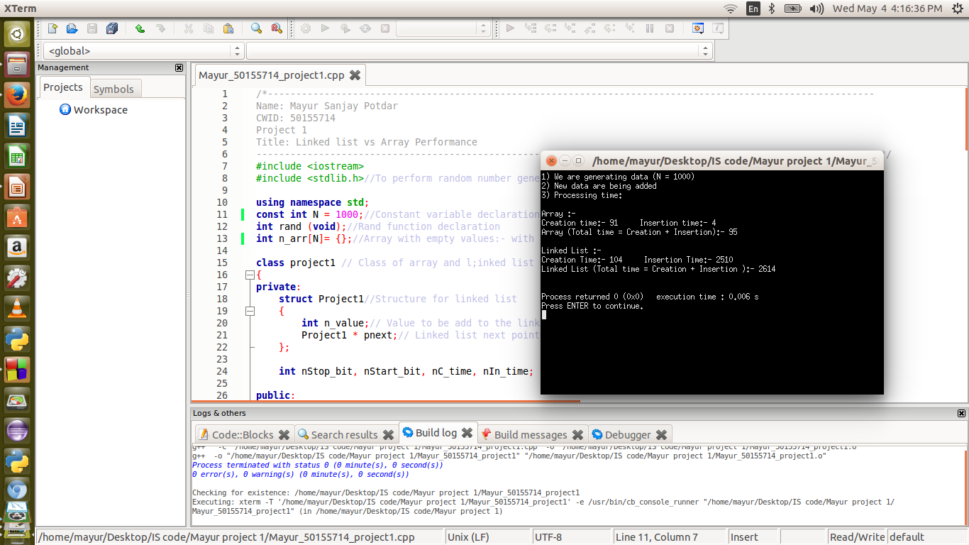
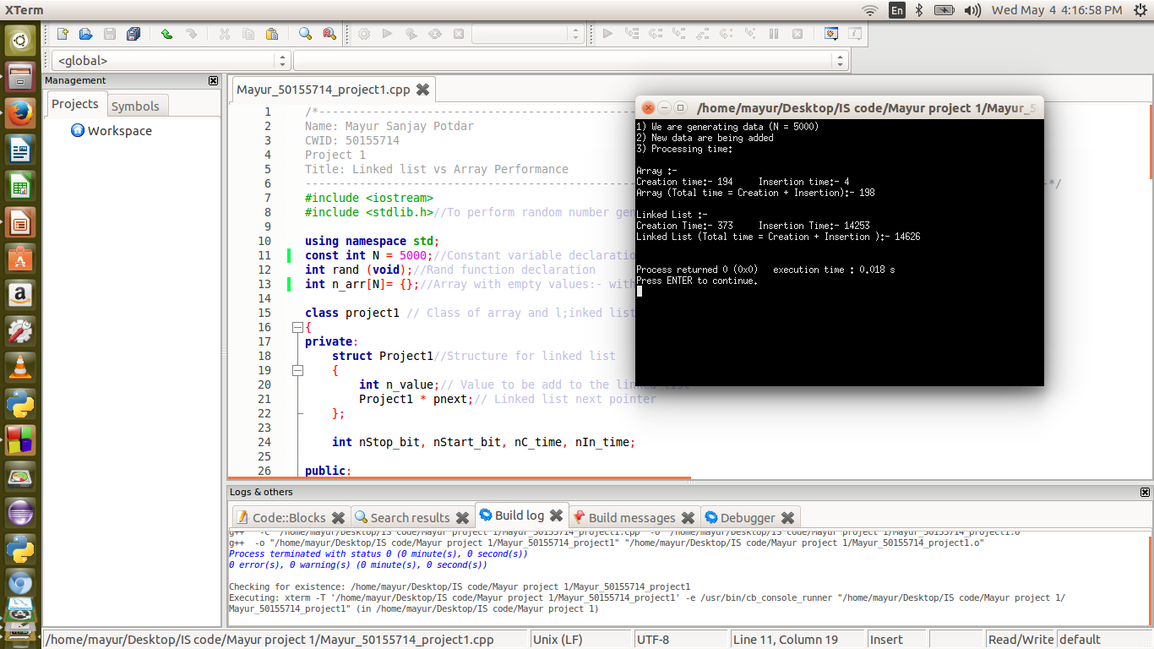
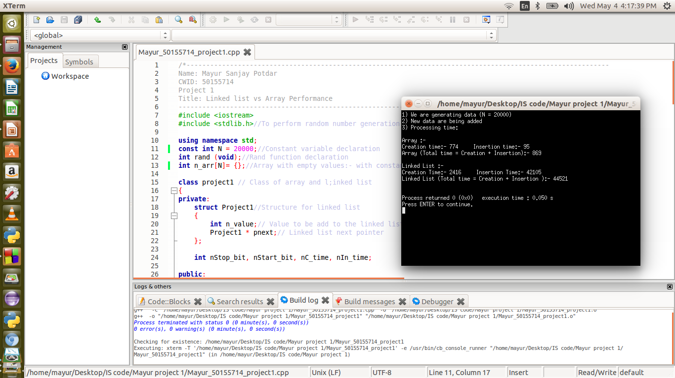

Figure 2. 5000 values for the comparison

Figure3. 1000 values for the comparison

Figure 4. 100 values for the comparison

Figure 4. 10000 values for the comparison

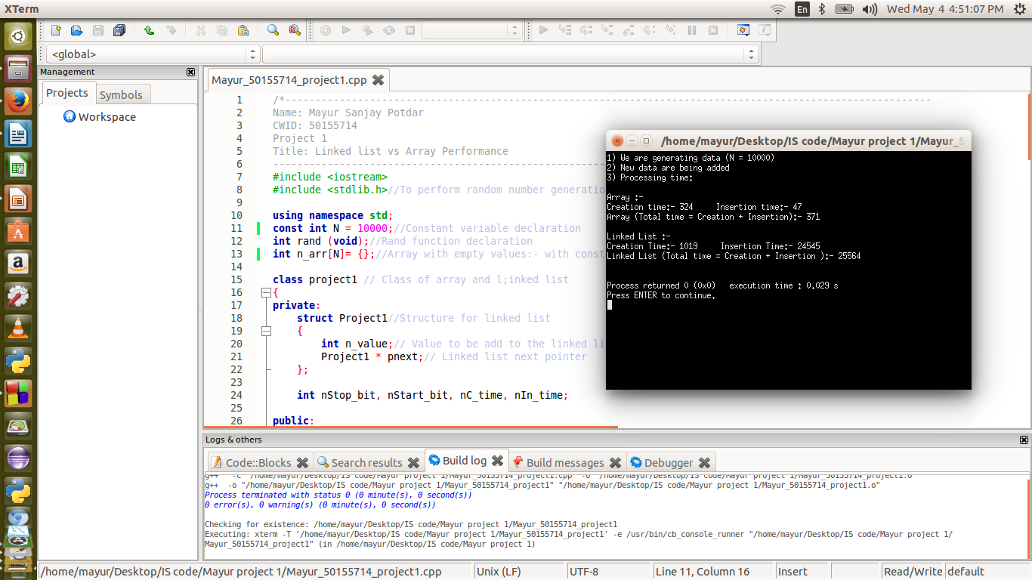

Performance analysis : - Array :-

Values | Time |  |  | Result
 | Creation | Insertion | Total Time
100 | 69 | 03 | 72 | Worst Case
1000 | 91 | 04 | 95 | Best Case
5000 | 191 | 04 | 198 | Best Case
10000 | 324 | 47 | 371 | Best Case
20000 | 774 | 95 | 869 | Best Case

Linked List :-

Values | Time |  |  | Result
 | Creation | Insertion | Total Time
100 | 13 | 37 | 50 | Best Case
1000 | 104 | 2150 | 2614 | Worst Case
5000 | 373 | 14253 | 14626 | Worst Case
10000 | 1019 | 24545 | 25564 | Worst Case
20000 | 2416 | 42105 | 44521 | Worst Case

Note : - For every execution values are changing according to the system clock

Flow chart difference and comparission
Figure 5. Creation with Initilization of array and linked list

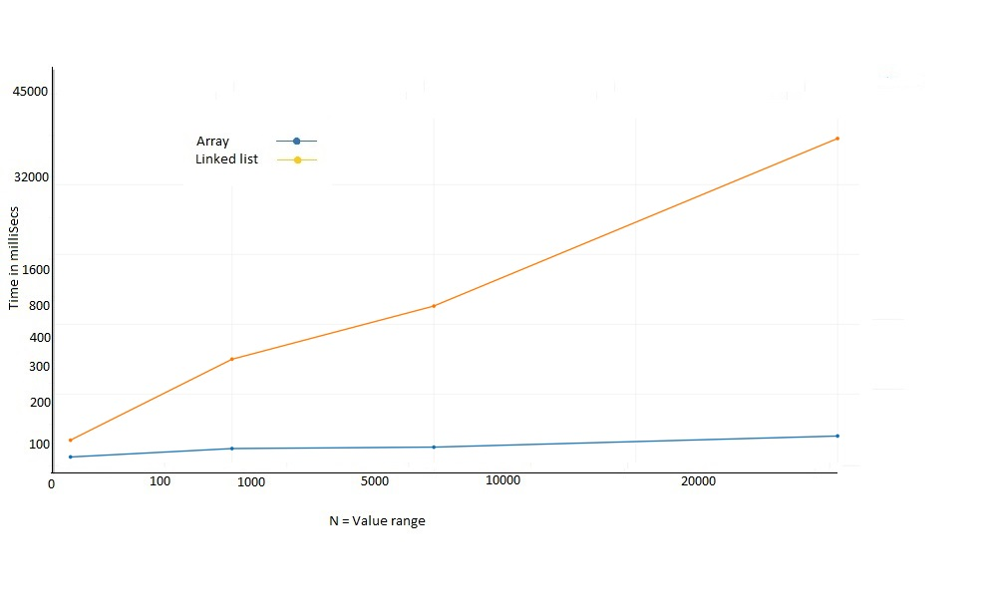

Figure 6. Value Insertion of array and linked list
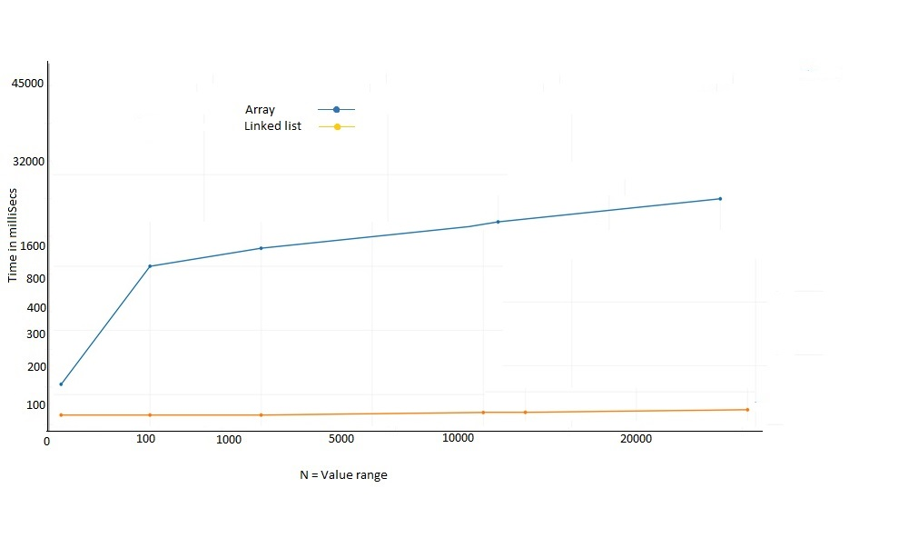

Figure 7. Final Result of array and linked list

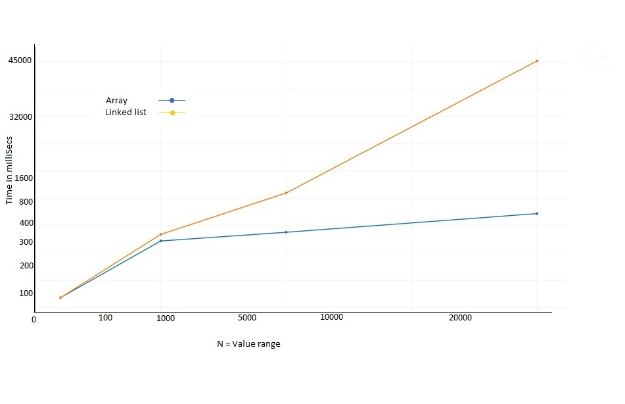
Conclusion:
Creation and initialization of an array is pretty best as compare to Linked list. Where as Insertion and deletion of linked list element is easy than an array. If values are maximum then performance of linked list is worst. But if you know the size of an array then array performs really well than linked list.

